A)

q_a omega_a q_b omega_b omega_tot

0 1.00e+00 100 4.53e+58 4.53e+58

1 2.00e+02 99 2.28e+58 4.55e+60

2 2.01e+04 98 1.14e+58 2.29e+62

3 1.35e+06 97 5.66e+57 7.66e+63

4 6.87e+07 96 2.80e+57 1.92e+65

5 2.80e+09 95 1.38e+57 3.86e+66

6 9.57e+10 94 6.75e+56 6.46e+67

7 2.82e+12 93 3.29e+56 9.27e+68

8 7.29e+13 92 1.59e+56 1.16e+70

9 1.68e+15 91 7.67e+55 1.29e+71

10 3.52e+16 90 3.67e+55 1.29e+72

11 6.72e+17 89 1.75e+55 1.18e+73

12 1.18e+19 88 8.28e+54 9.79e+73

13 1.93e+20 87 3.90e+54 7.51e+74

14 2.93e+21 86 1.82e+54 5.35e+75

15 4.18e+22 85 8.48e+53 3.55e+76

16 5.62e+23 84 3.92e+53 2.20e+77

17 7.14e+24 83 1.80e+53 1.28e+78

18 8.61e+25 82 8.20e+52 7.06e+78

19 9.88e+26 81 3.71e+52 3.67e+79

20 1.08e+28 80 1.67e+52 1.81e+80

21 1.13e+29 79 7.47e+51 8.47e+80

22 1.14e+30 78 3.31e+51 3.77e+81

23 1.10e+31 77 1.46e+51 1.61e+82

24 1.02e+32 76 6.39e+50 6.53e+82

25 9.15e+32 75 2.78e+50 2.54e+83

26 7.92e+33 74 1.20e+50 9.47e+83

27 6.63e+34 73 5.12e+49 3.39e+84

28 5.37e+35 72 2.17e+49 1.17e+85

29 4.22e+36 71 9.14e+48 3.86e+85

30 3.23e+37 70 3.82e+48 1.23e+86

31 2.39e+38 69 1.58e+48 3.78e+86

32 1.73e+39 68 6.50e+47 1.12e+87

33 1.21e+40 67 2.65e+47 3.21e+87

34 8.32e+40 66 1.07e+47 8.88e+87

35 5.56e+41 65 4.27e+46 2.38e+88

36 3.63e+42 64 1.69e+46 6.15e+88

37 2.32e+43 63 6.65e+45 1.54e+89

38 1.44e+44 62 2.58e+45 3.73e+89

39 8.82e+44 61 9.95e+44 8.78e+89

40 5.27e+45 60 3.79e+44 2.00e+90

41 3.08e+46 59 1.43e+44 4.42e+90

42 1.77e+47 58 5.35e+43 9.46e+90

43 9.96e+47 57 1.98e+43 1.97e+91

44 5.50e+48 56 7.22e+42 3.97e+91

45 2.98e+49 55 2.61e+42 7.78e+91

46 1.59e+50 54 9.31e+41 1.48e+92

47 8.31e+50 53 3.29e+41 2.73e+92

48 4.28e+51 52 1.15e+41 4.90e+92

49 2.17e+52 51 3.95e+40 8.55e+92

50 1.08e+53 50 1.34e+40 1.45e+93

51 5.29e+53 49 4.50e+39 2.38e+93

52 2.55e+54 48 1.49e+39 3.80e+93

53 1.21e+55 47 4.87e+38 5.91e+93

54 5.68e+55 46 1.57e+38 8.91e+93

55 2.62e+56 45 4.97e+37 1.30e+94

56 1.20e+57 44 1.55e+37 1.86e+94

57 5.37e+57 43 4.78e+36 2.57e+94

58 2.38e+58 42 1.45e+36 3.44e+94

59 1.04e+59 41 4.31e+35 4.48e+94

60 4.49e+59 40 1.26e+35 5.67e+94

61 1.91e+60 39 3.63e+34 6.95e+94

62 8.06e+60 38 1.03e+34 8.27e+94

63 3.35e+61 37 2.85e+33 9.54e+94

64 1.38e+62 36 7.75e+32 1.07e+95

65 5.59e+62 35 2.07e+32 1.16e+95

66 2.25e+63 34 5.40e+31 1.21e+95

67 8.91e+63 33 1.38e+31 1.23e+95

68 3.50e+64 32 3.45e+30 1.21e+95

69 1.36e+65 31 8.43e+29 1.15e+95

70 5.22e+65 30 2.01e+29 1.05e+95

71 1.99e+66 29 4.67e+28 9.28e+94

72 7.48e+66 28 1.06e+28 7.92e+94

73 2.79e+67 27 2.33e+27 6.50e+94

74 1.03e+68 26 5.00e+26 5.14e+94

75 3.75e+68 25 1.04e+26 3.91e+94

76 1.36e+69 24 2.10e+25 2.85e+94

77 4.87e+69 23 4.09e+24 1.99e+94

78 1.73e+70 22 7.72e+23 1.33e+94

79 6.09e+70 21 1.40e+23 8.54e+93

80 2.12e+71 20 2.46e+22 5.21e+93

81 7.34e+71 19 4.13e+21 3.03e+93

82 2.51e+72 18 6.64e+20 1.67e+93

83 8.54e+72 17 1.02e+20 8.73e+92

84 2.88e+73 16 1.50e+19 4.31e+92

85 9.62e+73 15 2.08e+18 2.00e+92

86 3.19e+74 14 2.74e+17 8.74e+91

87 1.05e+75 13 3.40e+16 3.56e+91

88 3.42e+75 12 3.94e+15 1.35e+91

89 1.11e+76 11 4.26e+14 4.71e+90

90 3.55e+76 10 4.26e+13 1.51e+90

91 1.13e+77 9 3.91e+12 4.43e+89

92 3.58e+77 8 3.26e+11 1.17e+89

93 1.12e+78 7 2.44e+10 2.74e+88

94 3.50e+78 6 1.61e+09 5.64e+87

95 1.08e+79 5 9.20e+07 9.97e+86

96 3.33e+79 4 4.42e+06 1.47e+86

97 1.02e+80 3 1.72e+05 1.75e+85

98 3.08e+80 2 5.05e+03 1.56e+84

99 9.27e+80 1 1.00e+02 9.27e+82

100 2.77e+81 0 1.00e+00 2.77e+81

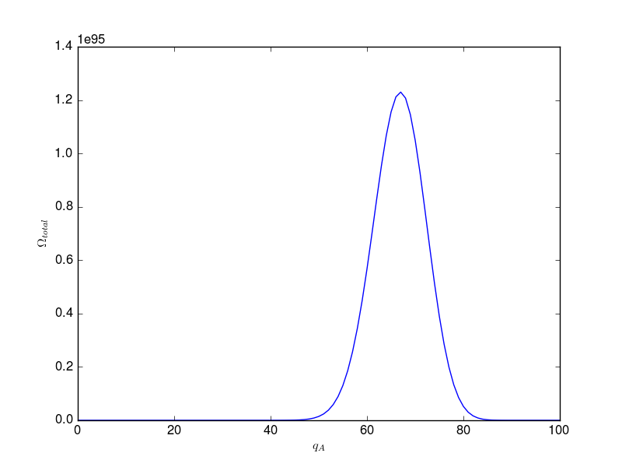

B) The most probable macrostate corresponds to qA = 67 and qB = 33. The probability of this is 0.0732.

The least probable macrostate corresponds to qA = 0 and qB = 100. The probability of this is 2.69x10-38.

C)

q_a omega_a S_a/k q_b omega_b S_b/k omega_tot S_tot/k

0 1.00e+00 0.00 100 4.53e+58 135.06 4.53e+58 135.06

1 2.00e+02 5.30 99 2.28e+58 134.37 4.55e+60 139.67

2 2.01e+04 9.91 98 1.14e+58 133.68 2.29e+62 143.59

3 1.35e+06 14.12 97 5.66e+57 132.98 7.66e+63 147.10

4 6.87e+07 18.05 96 2.80e+57 132.28 1.92e+65 150.32

5 2.80e+09 21.75 95 1.38e+57 131.57 3.86e+66 153.32

6 9.57e+10 25.28 94 6.75e+56 130.85 6.46e+67 156.14

7 2.82e+12 28.67 93 3.29e+56 130.14 9.27e+68 158.80

8 7.29e+13 31.92 92 1.59e+56 129.41 1.16e+70 161.33

9 1.68e+15 35.06 91 7.67e+55 128.68 1.29e+71 163.74

10 3.52e+16 38.10 90 3.67e+55 127.94 1.29e+72 166.04

11 6.72e+17 41.05 89 1.75e+55 127.20 1.18e+73 168.25

12 1.18e+19 43.92 88 8.28e+54 126.45 9.79e+73 170.37

13 1.93e+20 46.71 87 3.90e+54 125.70 7.51e+74 172.41

14 2.93e+21 49.43 86 1.82e+54 124.94 5.35e+75 174.37

15 4.18e+22 52.09 85 8.48e+53 124.17 3.55e+76 176.26

16 5.62e+23 54.69 84 3.92e+53 123.40 2.20e+77 178.09

17 7.14e+24 57.23 83 1.80e+53 122.62 1.28e+78 179.85

18 8.61e+25 59.72 82 8.20e+52 121.84 7.06e+78 181.56

19 9.88e+26 62.16 81 3.71e+52 121.05 3.67e+79 183.20

20 1.08e+28 64.55 80 1.67e+52 120.25 1.81e+80 184.80

21 1.13e+29 66.90 79 7.47e+51 119.44 8.47e+80 186.34

22 1.14e+30 69.21 78 3.31e+51 118.63 3.77e+81 187.84

23 1.10e+31 71.47 77 1.46e+51 117.81 1.61e+82 189.29

24 1.02e+32 73.70 76 6.39e+50 116.98 6.53e+82 190.69

25 9.15e+32 75.90 75 2.78e+50 116.15 2.54e+83 192.05

26 7.92e+33 78.05 74 1.20e+50 115.31 9.47e+83 193.36

27 6.63e+34 80.18 73 5.12e+49 114.46 3.39e+84 194.64

28 5.37e+35 82.27 72 2.17e+49 113.60 1.17e+85 195.87

29 4.22e+36 84.33 71 9.14e+48 112.74 3.86e+85 197.07

30 3.23e+37 86.37 70 3.82e+48 111.86 1.23e+86 198.23

31 2.39e+38 88.37 69 1.58e+48 110.98 3.78e+86 199.35

32 1.73e+39 90.35 68 6.50e+47 110.09 1.12e+87 200.44

33 1.21e+40 92.30 67 2.65e+47 109.19 3.21e+87 201.49

34 8.32e+40 94.22 66 1.07e+47 108.29 8.88e+87 202.51

35 5.56e+41 96.12 65 4.27e+46 107.37 2.38e+88 203.49

36 3.63e+42 98.00 64 1.69e+46 106.45 6.15e+88 204.44

37 2.32e+43 99.85 63 6.65e+45 105.51 1.54e+89 205.36

38 1.44e+44 101.68 62 2.58e+45 104.57 3.73e+89 206.25

39 8.82e+44 103.49 61 9.95e+44 103.61 8.78e+89 207.10

40 5.27e+45 105.28 60 3.79e+44 102.65 2.00e+90 207.93

41 3.08e+46 107.05 59 1.43e+44 101.67 4.42e+90 208.72

42 1.77e+47 108.79 58 5.35e+43 100.69 9.46e+90 209.48

43 9.96e+47 110.52 57 1.98e+43 99.69 1.97e+91 210.21

44 5.50e+48 112.23 56 7.22e+42 98.69 3.97e+91 210.91

45 2.98e+49 113.92 55 2.61e+42 97.67 7.78e+91 211.59

46 1.59e+50 115.59 54 9.31e+41 96.64 1.48e+92 212.23

47 8.31e+50 117.25 53 3.29e+41 95.60 2.73e+92 212.84

48 4.28e+51 118.89 52 1.15e+41 94.54 4.90e+92 213.43

49 2.17e+52 120.51 51 3.95e+40 93.48 8.55e+92 213.98

50 1.08e+53 122.11 50 1.34e+40 92.40 1.45e+93 214.51

51 5.29e+53 123.70 49 4.50e+39 91.31 2.38e+93 215.01

52 2.55e+54 125.28 48 1.49e+39 90.20 3.80e+93 215.48

53 1.21e+55 126.84 47 4.87e+38 89.08 5.91e+93 215.92

54 5.68e+55 128.38 46 1.57e+38 87.95 8.91e+93 216.33

55 2.62e+56 129.91 45 4.97e+37 86.80 1.30e+94 216.71

56 1.20e+57 131.43 44 1.55e+37 85.64 1.86e+94 217.06

57 5.37e+57 132.93 43 4.78e+36 84.46 2.57e+94 217.39

58 2.38e+58 134.42 42 1.45e+36 83.26 3.44e+94 217.68

59 1.04e+59 135.89 41 4.31e+35 82.05 4.48e+94 217.94

60 4.49e+59 137.35 40 1.26e+35 80.82 5.67e+94 218.18

61 1.91e+60 138.80 39 3.63e+34 79.58 6.95e+94 218.38

62 8.06e+60 140.24 38 1.03e+34 78.31 8.27e+94 218.56

63 3.35e+61 141.67 37 2.85e+33 77.03 9.54e+94 218.70

64 1.38e+62 143.08 36 7.75e+32 75.73 1.07e+95 218.81

65 5.59e+62 144.48 35 2.07e+32 74.41 1.16e+95 218.89

66 2.25e+63 145.87 34 5.40e+31 73.07 1.21e+95 218.94

67 8.91e+63 147.25 33 1.38e+31 71.70 1.23e+95 218.95

68 3.50e+64 148.62 32 3.45e+30 70.32 1.21e+95 218.93

69 1.36e+65 149.98 31 8.43e+29 68.91 1.15e+95 218.88

70 5.22e+65 151.32 30 2.01e+29 67.47 1.05e+95 218.79

71 1.99e+66 152.66 29 4.67e+28 66.01 9.28e+94 218.67

72 7.48e+66 153.98 28 1.06e+28 64.53 7.92e+94 218.51

73 2.79e+67 155.30 27 2.33e+27 63.02 6.50e+94 218.32

74 1.03e+68 156.60 26 5.00e+26 61.48 5.14e+94 218.08

75 3.75e+68 157.90 25 1.04e+26 59.91 3.91e+94 217.81

76 1.36e+69 159.18 24 2.10e+25 58.31 2.85e+94 217.49

77 4.87e+69 160.46 23 4.09e+24 56.67 1.99e+94 217.13

78 1.73e+70 161.73 22 7.72e+23 55.00 1.33e+94 216.73

79 6.09e+70 162.99 21 1.40e+23 53.30 8.54e+93 216.28

80 2.12e+71 164.24 20 2.46e+22 51.56 5.21e+93 215.79

81 7.34e+71 165.48 19 4.13e+21 49.77 3.03e+93 215.25

82 2.51e+72 166.71 18 6.64e+20 47.95 1.67e+93 214.65

83 8.54e+72 167.93 17 1.02e+20 46.07 8.73e+92 214.00

84 2.88e+73 169.15 16 1.50e+19 44.15 4.31e+92 213.30

85 9.62e+73 170.35 15 2.08e+18 42.18 2.00e+92 212.53

86 3.19e+74 171.55 14 2.74e+17 40.15 8.74e+91 211.70

87 1.05e+75 172.74 13 3.40e+16 38.06 3.56e+91 210.80

88 3.42e+75 173.92 12 3.94e+15 35.91 1.35e+91 209.83

89 1.11e+76 175.10 11 4.26e+14 33.69 4.71e+90 208.78

90 3.55e+76 176.26 10 4.26e+13 31.38 1.51e+90 207.65

91 1.13e+77 177.42 9 3.91e+12 28.99 4.43e+89 206.42

92 3.58e+77 178.57 8 3.26e+11 26.51 1.17e+89 205.08

93 1.12e+78 179.72 7 2.44e+10 23.92 2.74e+88 203.63

94 3.50e+78 180.86 6 1.61e+09 21.20 5.64e+87 202.05

95 1.08e+79 181.98 5 9.20e+07 18.34 9.97e+86 200.32

96 3.33e+79 183.11 4 4.42e+06 15.30 1.47e+86 198.41

97 1.02e+80 184.22 3 1.72e+05 12.05 1.75e+85 196.28

98 3.08e+80 185.33 2 5.05e+03 8.53 1.56e+84 193.86

99 9.27e+80 186.43 1 1.00e+02 4.61 9.27e+82 191.04

100 2.77e+81 187.53 0 1.00e+00 0.00 2.77e+81 187.53

The red curve corresponds to A, blue corresponds to B, and green corresponds to the total entropy.

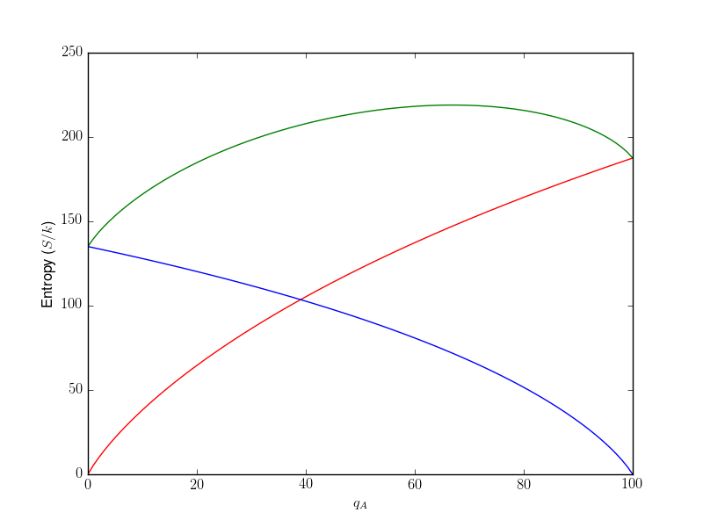

This program was coded in Python 2.7

# Matt Meyers, PHYS 309-010

import numpy as np

import matplotlib.pyplot as plt

import math

# Assigning constants for number of oscillators and total energy

N_A = 200

N_B = 100

Q = 100

# Putting macrostates for a and b into lists

q_a = np.arange(0, Q + 1)

q_b = Q - q_a

# Calculating omega for a and b and assigning these values to lists

omegaA = np.empty(shape=[Q + 1])

for i in range(0, Q + 1):

omegaA[i] = (math.factorial(q_a[i] + N_A - 1)) / (math.factorial(q_a[i]) * math.factorial(N_A - 1))

omegaB = np.empty(shape=[Q + 1])

for i in range(0, Q + 1):

omegaB[i] = (math.factorial(q_b[i] + N_B - 1)) / (math.factorial(q_b[i]) * math.factorial(N_B - 1))

# Omega total is the product of omega_a and omega_b

omegaTot = omegaA * omegaB

#Printing table for testing

for i in range(0,Q +1):

print(q_a[i],"\t","{:.2e}".format(omegaA[i]),"\t",q_b[i],"\t",

"{:.2e}".format(omegaB[i]),"\t","{:.2e}".format(omegaTot[i]))

# Plotting Omega_total versus number of macrostates for a

plt.plot(q_a, omegaTot)

plt.rc('text', usetex=True)

plt.xlabel(r"$q_A$")

plt.ylabel(r"$\Omega_{total}$")

plt.savefig("MicrostatesPlot.png")

plt.show()

# The most probable macrostate would be q_a = 67. The probability of this would be the following.

mostProbable = omegaTot[67] / sum(omegaTot)

print("{:.2e}".format(mostProbable))

# The least probable macrostate would be q_a = 0. The probability of this would be the following.

leastProbable = omegaTot[0] / sum(omegaTot)

print("{:.2e}".format(leastProbable))

# Calculating entropy for a and b. Then saving these values to lists in terms of Boltzmann's constant, the entropy is

# the natural log of the number of microstates.

s_a = np.empty(shape=[Q + 1])

for i in range(0, Q + 1):

s_a[i] = math.log(omegaA[i])

s_b = np.empty(shape=[Q + 1])

for i in range(0, Q + 1):

s_b[i] = math.log(omegaB[i])

s_tot = np.empty(shape=[Q + 1])

for i in range(0, Q + 1):

s_tot[i] = math.log(omegaTot[i])

# Plotting the entropies against the number of macrostates for a. A is the red curve, B is blue, and the total is green.

plt.plot(q_a, s_a, 'r', q_a, s_b, 'b', q_a, s_tot, 'g')

plt.rc('text', usetex=True)

plt.xlabel(r"$q_A$")

plt.ylabel(r"Entropy ($S/k$)")

plt.savefig("EntropyPlot.png")

plt.show()

# Formatting the data for omega and writing to a text file.

file = open("MicrostateTable.txt", "w")

for i in range(0,102):

if i == 0:

file.write("q_a\tomega_a\t\tq_b\tomega_b\t\tomega_tot")

file.write("\n")

else:

file.write(str(q_a[i-1])+"\t"+str("{:.2e}".format(omegaA[i-1]))+"\t"+str(q_b[i-1])+"\t"+

str("{:.2e}".format(omegaB[i-1]))+"\t"+str("{:.2e}".format(omegaTot[i-1])))

file.write("\n")

# Formatting the entropy data and printing to a text file.

file = open("EntropyTable.txt", "w")

for i in range(0,102):

if i == 0:

file.write("q_a\tomega_a\t\tS_a/k\tq_b\tomega_b\t\tS_b/k\t\tomega_tot\tS_tot/k")

file.write("\n")

else:

file.write(str(q_a[i-1])+"\t"+str("{:.2e}".format(omegaA[i-1]))+"\t"+str("{:.2f}".format(s_a[i-1]))

+"\t"+str(q_b[i-1])+"\t"+str("{:.2e}".format(omegaB[i-1]))+"\t"+str("{:.2f}".format(s_b[i-1]))+"\t\t"

+str("{:.2e}".format(omegaTot[i-1]))+"\t"+str("{:.2f}".format(s_tot[i-1])))

file.write("\n")